6A^{th} Grade: Unit 8, Lesson 6

- To determine the amount of water needed to fill a fish tank, what would need to be calculated?

The volume of the tank

- To determine how much wood would be needed to make a birdhouse in the shape of a rectangular prism, what would need to be calculated?

The surface area of the birdhouse

- What is the total area of the composite figure?
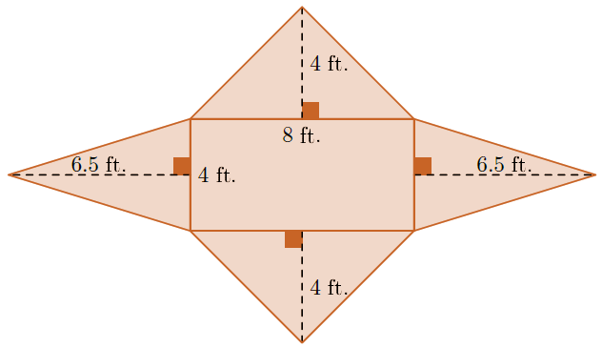
90 ft²

